AFREEN BABU BASHA

DATA ANALYTICS

University Success Analysis

**Project Overview**

The aim of this project is to conduct a comprehensive analysis of global university rankings using a rich dataset that includes information about universities, ranking systems, evaluation criteria, and historical performance metrics. By leveraging this dataset, we seek to gain valuable insights into the factors influencing university rankings, track the evolution of universities’ standings over time, and identify patterns in the global higher education landscape.

**Objectives**

1. **Analyse Ranking Factors:** Identify key criteria used in university rankings, such as academic reputation, faculty-student ratio, research output, international student enrolment, and employer reputation.
2. **Historical Performance Tracking:** Examine trends in university rankings over time to assess institutions' progress or decline.
3. **Regional Comparisons:** Compare rankings across different countries and regions to determine global trends in higher education.
4. **Influence of Internationalization:** Assess how factors like the percentage of international students and faculty affect rankings.
5. **Statistical Correlations:** Investigate relationships between various ranking factors, such as research funding and academic performance, to determine what significantly impacts a university's standing.

**Methodology**

* **Data Collection:** Utilize datasets from global ranking systems such as QS World University Rankings, Times Higher Education (THE), and Academic Ranking of World Universities (ARWU).
* **Data Cleaning & Preprocessing:** Remove inconsistencies, handle missing data, and normalize ranking scores for accurate comparisons.
* **Exploratory Data Analysis (EDA):** Use statistical and visualization techniques to uncover key trends and distributions in the dataset.
* **Visualization & Reporting:** Create charts, graphs, and dashboards to present findings effectively.

**Expected Outcomes**

* A detailed understanding of the factors influencing university rankings.
* Insights into the historical trends and performance variations of universities globally.
* Identification of key strengths and weaknesses of institutions based on ranking criteria.
* Recommendations for universities to improve their rankings based on data-driven analysis.

# 

**Data Base**

**Table named country**

1. id –Primary Key, a unique identifier for each country in the table.
2. Country name – Stores the name of the country.
3. population – Represents the population of the country.
4. GDP – Stores the Gross Domestic Product (GDP) of the country.

**Table named ranking criteria**

1. **id** → A unique identifier for each ranking criterion. It serves as the **Primary Key (PK)** for the table.

2. **ranking syst** → Specifies the ranking system

3. **criteria name** → The specific criterion used to assess universities

**Table named ranking system**

1. **id** → A unique identifier for each ranking system, serving as the **Primary Key (PK)**.

2. **system name** → The name of the ranking system

**Table name university**

1. **id** → A unique identifier for each university, serving as the **Primary Key** .

2. **country id** → A foreign key that links to the **country** table, identifying the country where the university is located.

3. **university name** → The name of the university

**Table named university ranking year**

1. university id → Foreign key referencing the university table, linking the ranking data to a specific university.

2. ranking crite → Likely a foreign key referring to the ranking criteria table, specifying the ranking factor (e.g., academic reputation, student-staff ratio).

3. year→ The year in which the ranking was recorded, allowing trend analysis over time.

4. score → The ranking score assigned to the university for the given year and ranking criteria.

**Table named university university year**

1. university id → Foreign key linking to the university table, identifying the specific university.

2. year_ → The academic year for which the data is recorded, enabling time-based analysis.

3. num students → The total number of students enrolled in the university for that year.

4. student staff ratio → The ratio of students to academic staff, which can influence university rankings and quality of education.

5. pct international students → The percentage of international students, reflecting the university’s global appeal.

6. pct female students → The percentage of female students enrolled, useful for analysing gender diversity in higher education.

ER DIAGRAM



The ER Diagram represents a relational database schema for university rankings. It includes entities such as **university, country, ranking system, ranking criteria, university ranking year, and university year**, connected through primary and foreign keys. The **university table** links to the **country table**, while **ranking criteria** and **ranking system** define the ranking framework. The **university ranking year** table stores ranking scores by criteria and year, and **university year** tracks student statistics like **number of students, female percentage, international student percentage, and staff ratio**. This schema helps analyze university performance and demographics effectively.

How many universities are there in each country

The United States has the highest number of universities by a large margin, followed by China. The United Kingdom, Japan, France, Germany, and Italy also have a significant presence. Canada, South Korea, and Australia rank moderately, reflecting their strong education systems. Emerging markets like India, Brazil, and Turkey have a smaller but growing number of universities. European countries like the Netherlands and Russia appear lower on the list. Overall, the distribution highlights the dominance of the U.S. and China in higher education, with Europe and Asia contributing significantly.

Top Universities.

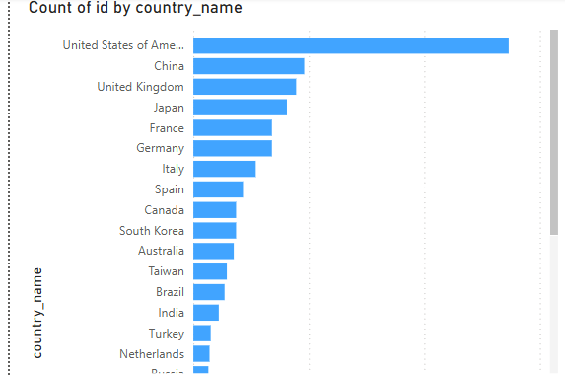

Bottom Universities

What is the distribution of international students across different countries

The distribution of international students varies significantly across countries, with the United States leading by a large margin, followed by the United Kingdom and Australia. These three countries have the highest number of international students due to their globally recognized universities, strong research facilities, and English-language education system. Switzerland, Germany, and the Netherlands also attract a substantial number of international students, benefiting from high-quality education and scholarship opportunities. Canada, France, and Hong Kong follow closely, maintaining steady international student enrollment. Countries like Singapore, Sweden, Belgium, and Denmark have relatively fewer international students but remain competitive due to specialized programs and research opportunities. Towards the lower end, Ireland, Japan, South Korea, Austria, China, and New Zealand have a smaller proportion of international students, likely due to language barriers or regional preferences. Overall, English-speaking countries dominate the list, while European and Asian nations also contribute significantly to the global student movement.

Which country has the highest number of female students enrolled in universities?

The **University of Vienna** has the highest number of female students enrolled, followed by **LMU Munich** and **King’s College London**, indicating a strong female presence in European universities. Other universities with high female enrollment include **Leiden University, Utrecht University, Karolinska Institute, and Boston University**. In contrast, universities with the lowest female enrollment are mostly in **China, Russia, and technical institutes in Europe and North America**, highlighting a gender disparity in STEM-focused institutions.

What is the average score for universities according to each ranking system.

The **Center for World University Rankings (CWUR)** assigns the highest average score to universities, significantly surpassing other ranking systems. The **Times Higher Education World University Rankings (THE)** has a moderate average score, while the **Shanghai Ranking** (also known as the Academic Ranking of World Universities - ARWU) assigns the lowest average score among the three. This suggests that CWUR uses a broader scoring scale, whereas THE and Shanghai Rankings may use stricter evaluation criteria or different methodologies, leading to lower average scores.

How does the ranking system affect a university's student-staff ratio.

The student-staff ratio varies significantly across different university ranking systems. The **Times Higher Education (THE) ranking system** accounts for the largest share (44.94%) of the total student-staff ratio, indicating that universities ranked by THE tend to have a relatively higher number of students per staff member. The **Center for World University Rankings (CWUR)** follows with 37.36%, suggesting a moderately balanced student-staff ratio. The **Shanghai Ranking (ARWU)** has the lowest proportion (17.7%), implying that universities ranked under this system generally maintain a lower student-staff ratio, potentially leading to better faculty availability and student engagement. This indicates that different ranking methodologies influence how universities structure their faculty-to-student distribution.

What are the most important criteria considered by ranking systems

The most important criteria considered by university ranking systems are **Alumni Employment Rank, Citations Rank, Influence Rank, Patents Rank, Publications Rank, Quality of Education Rank, and Quality of Faculty Rank**, as these have the highest count in the ranking criteria dataset. These factors emphasize research output, faculty quality, and the impact of graduates in the job market. Other notable criteria include **Citations, Income, Internationalization, Research, and Teaching**, indicating the significance of academic influence, financial strength, and global engagement. Lower-ranked factors such as **Awards, Highly Cited Researchers (HiCi), and Total Shanghai Ranking** also contribute but have less influence compared to the primary indicators.

Is there a correlation between a university's score and the number of international students

The scatter plot demonstrates a **positive correlation** between a university’s score and the percentage of international students. The trend line indicates that as the proportion of international students increases, the university’s score also tends to rise. This suggests that universities with a higher percentage of international students may have better global recognition, diverse academic environments, and stronger research collaborations, contributing to higher rankings. However, the presence of scattered data points also implies variability, meaning other factors like faculty quality, research output, and funding likely play significant roles in determining a university’s overall score.

How does the percentage of female students impact a university's ranking

The analysis examines the relationship between the percentage of female students and a university's ranking score. The scatter plot indicates a weak correlation, suggesting that the proportion of female students does not significantly impact a university's ranking. While some high-ranking universities have a substantial percentage of female students, the overall trend remains inconsistent. This implies that other ranking factors, such as academic reputation, faculty quality, research impact, and funding, play a more significant role in determining a university’s rank. However, fostering gender diversity remains essential for institutional growth, inclusivity, and equal opportunities in higher education.

Which university has the highest number of students

From the given bar chart, **Arizona State University** has the highest number of students among the listed universities. The bar for Arizona State University is significantly longer than the rest, indicating a much larger student population. Other universities with high student numbers include the **University of Massachusetts, University of Toronto, Indiana University, and Monash University**. These universities have a large student body due to their extensive programs, diverse course offerings, and strong global reputations. In contrast, universities with the smallest student populations, such as **Scuola Normale Superiore, Mines ParisTech, and Sabancı University**, have significantly fewer students, likely due to their specialized nature and smaller institutional sizes.

How does the percentage of international students vary across different universities

The percentage of international students varies significantly across different universities. Institutions like the California Institute of Technology, École Polytechnique, and École Normale Supérieure have the highest percentage of international students, indicating a strong global appeal. Conversely, universities such as the University of Florida, Simon Fraser University, and Texas A&M University have a significantly lower percentage of international students, suggesting a more domestically focused student population. This variation highlights differences in university policies, global outreach, and attractiveness to international applicants. 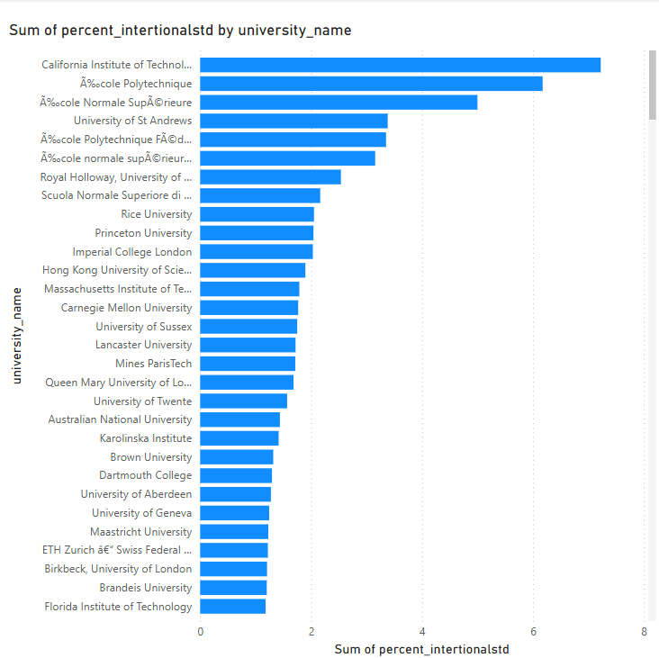

Is there a correlation between a university's ranking and its student-staff ratio.

The analysis indicates a weak negative correlation between university rankings and student-staff ratios, suggesting that higher-ranked universities generally tend to have lower student-staff ratios. However, the relationship is not strong, as universities with similar rankings exhibit significant variation in faculty availability. This implies that while student-staff ratio may contribute to rankings, other factors such as research impact, funding, and global reputation likely play a more significant role. Overall, the data suggests that a low student-staff ratio alone is not a definitive indicator of a university’s ranking but may enhance teaching quality.

How does the number of students in universities change over time

The number of students in universities showed a steady increase from 2011 to 2015, reflecting a positive growth trend in higher education enrollment. Each year, the student population grew, reaching its highest point in 2015. This growth could be attributed to factors such as improved access to education, increased international student admissions, and expanding university programs. However, in 2016, there was a significant drop in the total number of students, indicating a sharp decline compared to previous years. This sudden decrease may have been influenced by policy changes, economic downturns, visa restrictions, or shifts in student preferences. The drastic reduction in 2016 suggests a potential disruption in higher education trends that may require further analysis to understand the underlying causes.

Is there a correlation between a university's ranking score and the student-staff ratio over the years

The analysis of the correlation between a university’s ranking score and the student-staff ratio over multiple years indicates a strong positive relationship. As the ranking score increases, the student-staff ratio also rises, suggesting that highly ranked universities tend to accommodate more students per faculty member. This trend may be influenced by factors such as institutional growth, faculty recruitment policies, or shifts in ranking methodologies. The consistent pattern over different years reinforces the idea that student-staff ratios play a role in determining university rankings or reflect broader trends in higher education resource allocation.

How does the percentage of international students vary across different years

The bar chart illustrates the percentage of international students across different years from 2011 to 2016. From the data, there is a general upward trend from 2011 to 2014, where the percentage of international students gradually increases. The highest percentage is observed in 2014, followed closely by 2015, indicating a peak in international student enrollment during these years. However, a significant drop is noticeable in 2016, where the percentage declines sharply compared to previous years. This could be attributed to policy changes, visa restrictions, economic factors, or other external influences affecting student mobility. The overall trend suggests a stable increase until 2015, followed by a substantial decrease in 2016.

What is the impact of a university's ranking on the number of international students it attracts

The analysis reveals a positive correlation between a university’s ranking and the number of international students it attracts. Higher-ranked universities generally have a stronger global reputation, better research facilities, and more funding, making them more appealing to international students. As seen in the scatter plot, universities with higher scores tend to enroll a larger number of international students, suggesting that ranking plays a crucial role in student decisions. This trend highlights the competitive nature of global higher education, where institutions strive to enhance their rankings to attract a diverse and talented student body.

Is there a relationship between a university's ranking score and the percentage of female students enrolled

The scatter plot displays the relationship between a university's ranking score (X-axis) and the percentage of female students enrolled (Y-axis), with different colors representing various university IDs. The distribution of points suggests a weak positive correlation, as indicated by the dotted trend line. However, the percentage of female students remains relatively low across different scores, with only a few outliers showing a higher percentage. This suggests that a university's ranking score does not have a strong influence on female enrollment, as most universities have similar gender distributions regardless of their score.

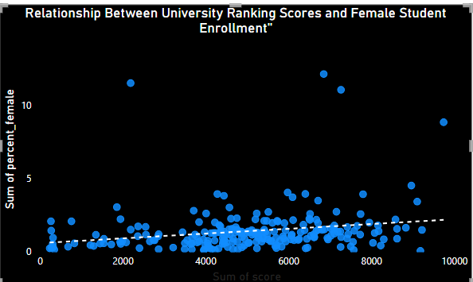

How does the percentage of international students affect a university's student-staff ratio

The scatter plot illustrates the relationship between the percentage of international students and the student-staff ratio at universities. The trend line suggests a weak negative correlation, indicating that as the percentage of international students increases, the student-staff ratio tends to decrease slightly. This implies that universities with a higher proportion of international students may have a lower student-to-staff ratio, potentially indicating better academic support and resources per student. However, the wide dispersion of data points suggests variability among universities, meaning other institutional factors may also play a significant role in determining student-staff ratios beyond just international student enrollment.

Are there any significant trends or patterns in the rankings of universities from different countries

The line chart displays the average ranking score of universities by country, revealing notable trends in global university rankings. Countries on the right, such as Switzerland, Denmark, and the Netherlands, have the lowest (best) average ranking scores, indicating the presence of high-ranking universities. On the other hand, countries on the left, including Puerto Rico, Uruguay, and the United Arab Emirates, have higher average scores, suggesting lower-ranked universities overall. The trend shows that European and North American countries generally dominate the top rankings, while universities from other regions, such as Latin America and parts of Asia, tend to have higher (worse) average ranking scores. This pattern may reflect differences in research funding, infrastructure, and academic reputation across different countries.

